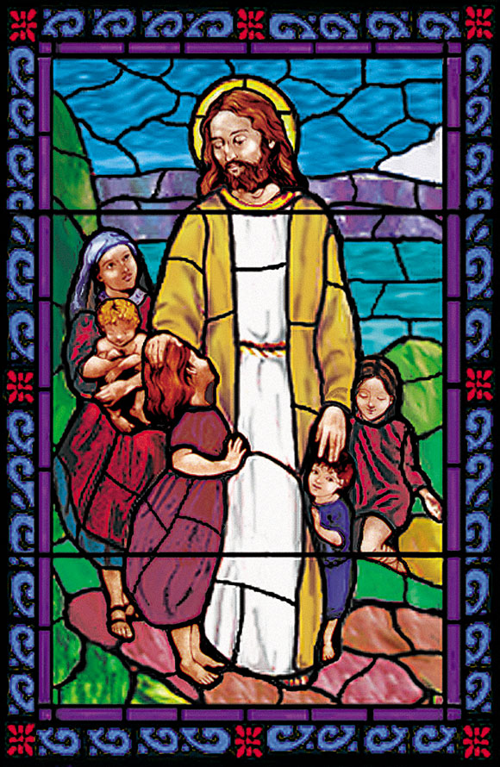

**Christ Episcopal Church**

**105 Cottage Place, Ridgewood, NJ 07450**

**201. 652. 2350** [www.christchurchridgewood.org](http://www.christchurchridgewood.org)

**2018 - 2019**

**Youth Programs Registration Form**

|  |  |  |  |
| --- | --- | --- | --- |
|  | Sunday School |  | Jubilation Choir (K - 12th grades) |
|  |  |  |  |
|  | Acolyte |  | Youth Sundays |
|  |  |  |  |
|  | Chimes |  | Readings |
|  |  |  |  |
|  | Nursery (infants – age 3) |  | Instrumentalist |
|  |  |  |  |
|  | Christmas Pageant (all ages) |  | Mission Trip (8th grade – college) |
|  |  |  |  |
|  | African Drumming (2nd -12th grades) |  | Journey to Adulthood (9th – 12th grades) |
|  |  |  |  |
|  | Youth Group |  | Assist Sunday School |

Youth’s Name: __________________________________________________________

Today’s Date: _______________ Youth’s Date of Birth: ______________________

Age (as of September 2018): _____ Grade (2018-2019 school year): _____

Parent (s) Names: ___________________________________________________

Home Address: ___________________________________________________________

E-mail address (s): ___________________________________________________

Phone contacts: ______________ ______________ _____________

Home Cell Cell

Notes *(please list any allergies, disabilities, or other information that you feel we should know about your child to enhance their experience)*:

_____________________________________________________________________

_____________________________________________________________________

Parents – What would you like to do to support the work of Christ Episcopal Church’s Youth Ministries?

______________________________________________________________________

Parents – Do you consent to have your child’s picture (without ID) used on the Christ Church website, local newspapers, Social Media sites (Facebook, Instagram, Twitter, etc.) and bulletin boards?

**Circle one:** Yes No